**MongoDB Practice**

**MongoDB CRUD Operations Example: Cricket Database**

**CRUD** (Create, Read, Update, Delete)

**Creating the Database and Collection**

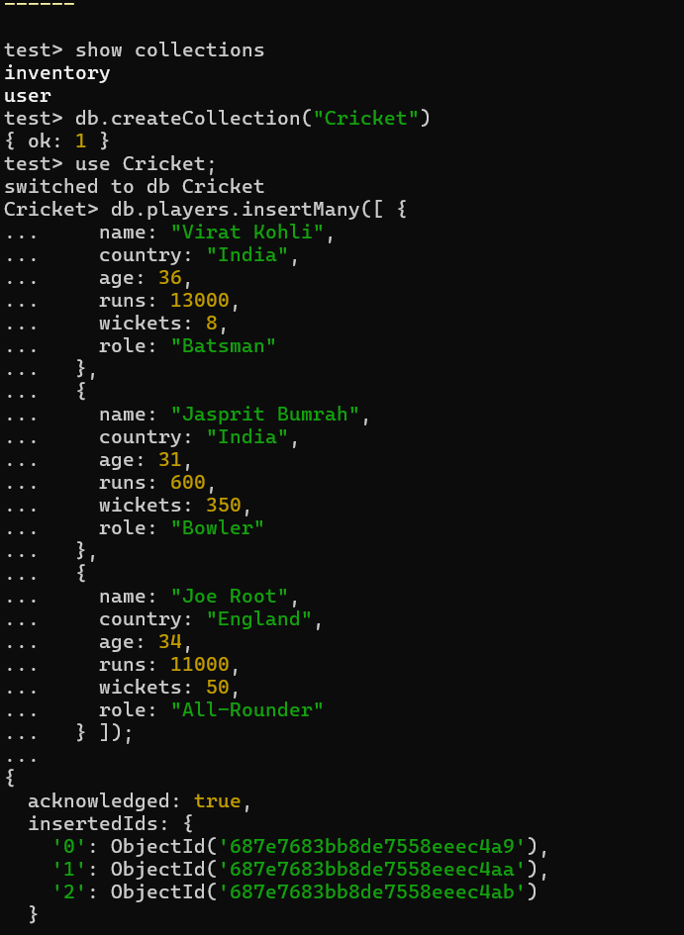

**CREATE: Inserting Documents**

Single and Multiple Documents

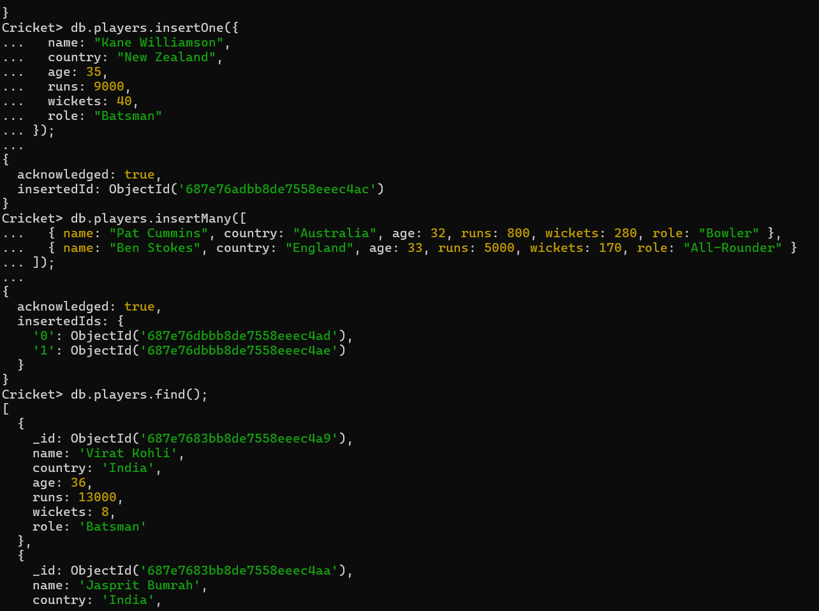

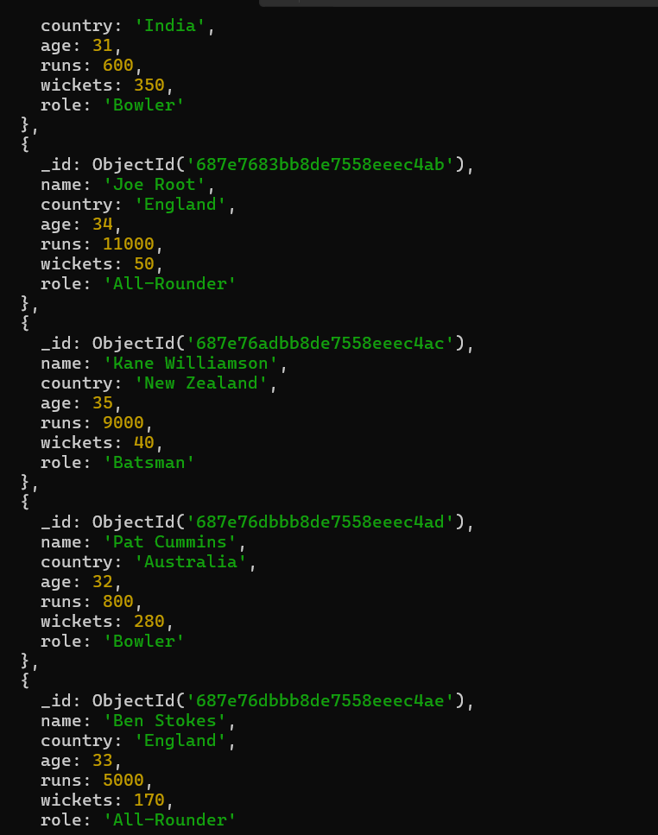

**READ: Finding Documents**

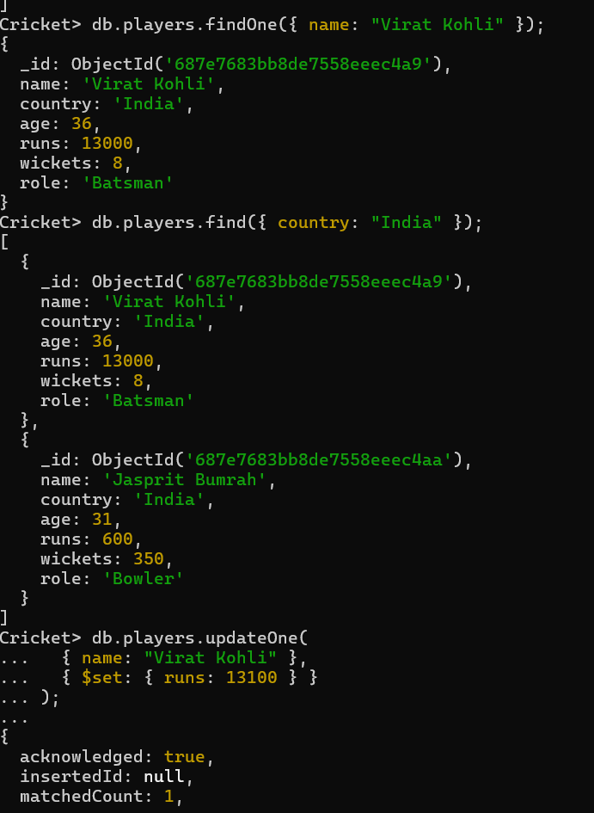

**UPDATE: Modifying Documents**

